1. Set up Trello  
   A screenshot of a computer

   Description automatically generated
2. Finied Slides for project pitch  
   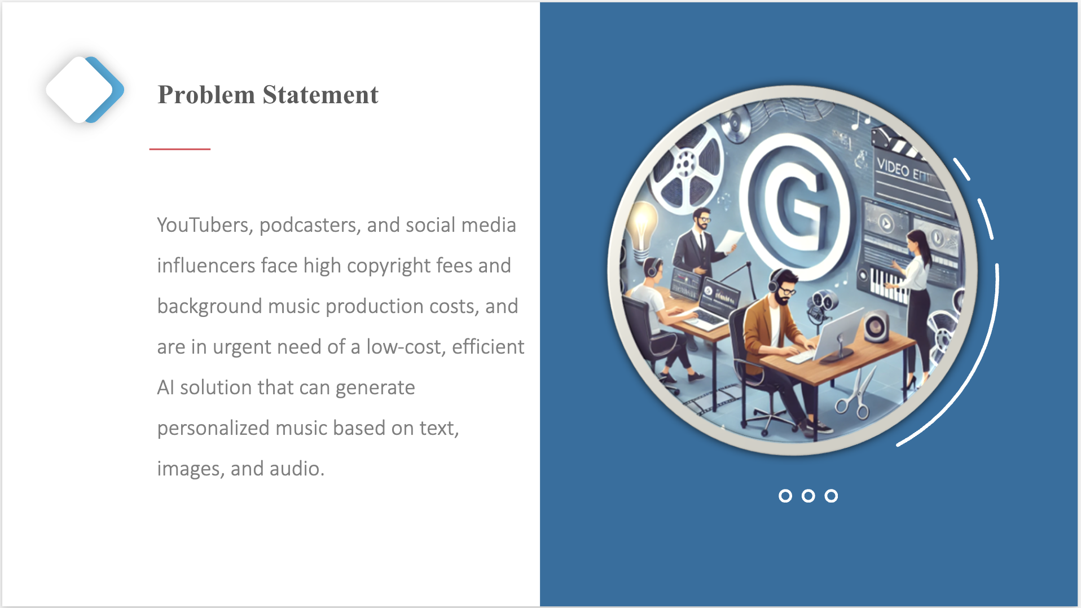  
   A screenshot of a computer screen

   Description automatically generated  
   A screenshot of a computer

   Description automatically generated
3. Team Charter   
   A white sheet with black text

   Description automatically generated